National University of Computer & Emerging Sciences, Karachi Computer Science Department
Course Code: SE-3003 | Course : Web Engineering Lab

Spring 2023, Lab Manual – 03
Javascript
JavaScript often abbreviated as JS, is a programming language that is one of the core
technologies of the World Wide Web, alongside HTML and CSS. As of 2022, 98% of websites use
JavaScript on the client side for webpage behavior, often incorporating third-party libraries. All
major web browsers have dedicated JavaScript engine to execute the code on users' devices.
JavaScript is a high-level, often just-in-time compiled language that conforms to the ECMAScript
standard. It has dynamic typing, prototype-based object-orientation, and first-class functions. It
is multi-paradigm, supporting event-driven, functional, and imperative programming styles. It
has application programming, interfaces (APIs) for working with text, dates, regular
expressions, standard data structures, and the Document Object Model (DOM).
The ECMAScript standard does not include any input/output (I/O), such as networking, storage,
or graphics facilities. In practice, the web browser or other runtime system provides JavaScript
APIs for I/O. JavaScript engines were originally used only in web browsers, but are now core
components of some servers and a variety of applications. The most popular runtime system
for this usage is Node.js. Although Java and JavaScript are similar in name, syntax, and
respective standard libraries, the two languages are distinct and differ greatly in design.

Getting Started with Javascript:

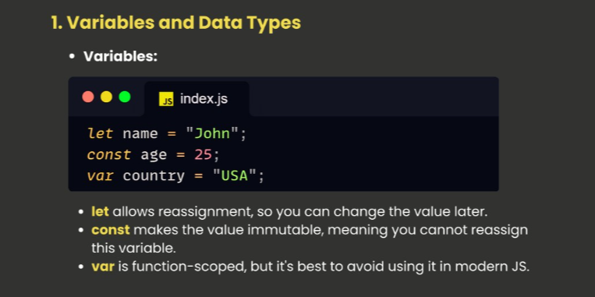
Code:
function checkScope() {
if (true) {
var a = "I am var"; // Function-scoped
let b = "I am let"; // Block-scoped
const c = "I am const"; // Block-scoped
}

console.log(a); // Accessible (function-scoped)
console.log(b); // ReferenceError: b is not defined (block-scoped)
console.log(c); // ReferenceError: c is not defined (block-scoped)
}

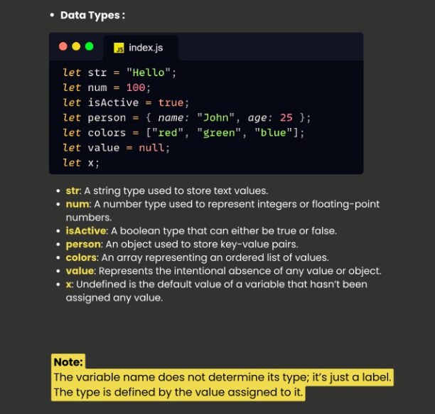
What is Hoisting:
Hoisting is JavaScript's default behavior of moving declarations to the top.In JavaScript, a variable can be declared after it has been used. Declarations are hoisted not the initialization values
//hoisting concept
console.log(a);
// ✅ Output: undefined
var a = 10; //declaration hoisted but not the value, so this will not be an error
console.log(b);
// ✅ Output: error: b is not defined
//error: because there is no declaration

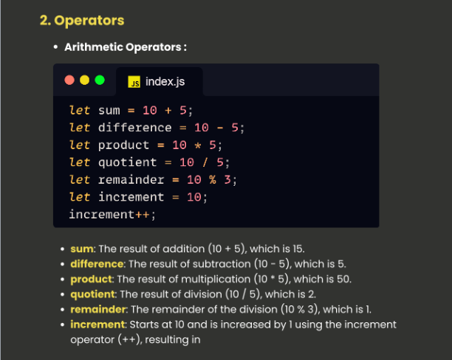
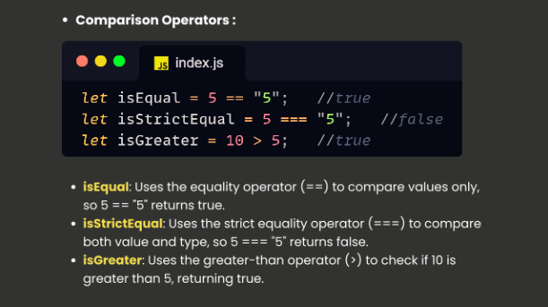
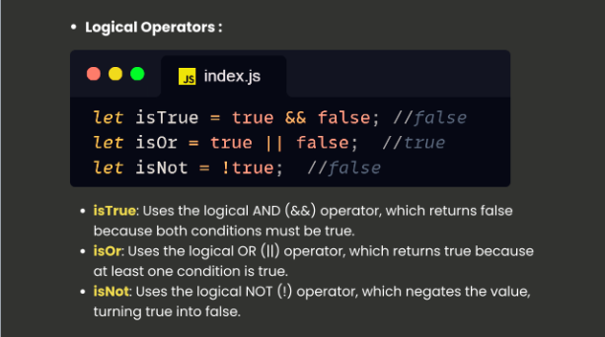

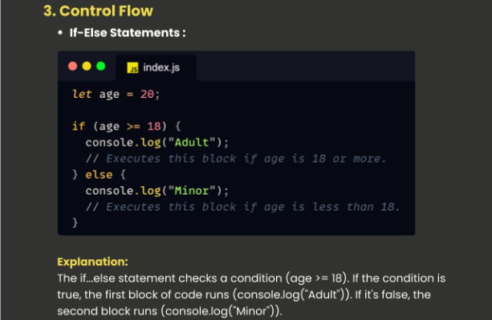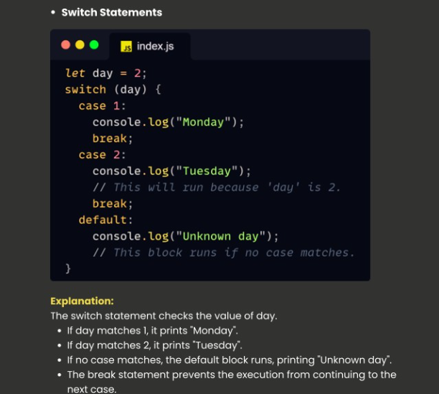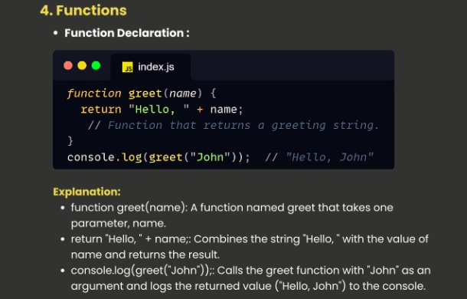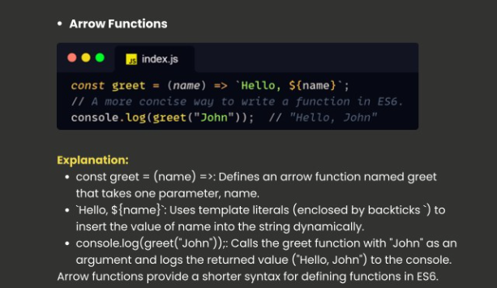

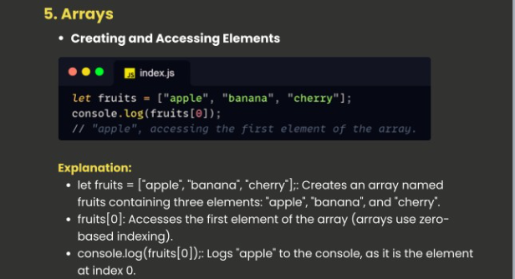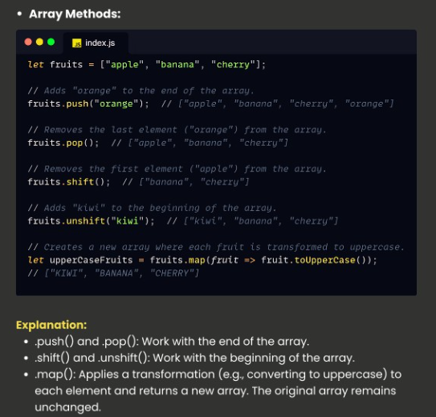
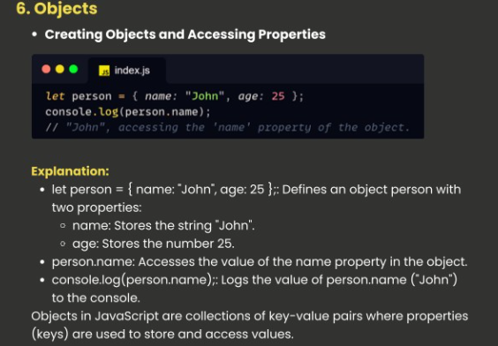
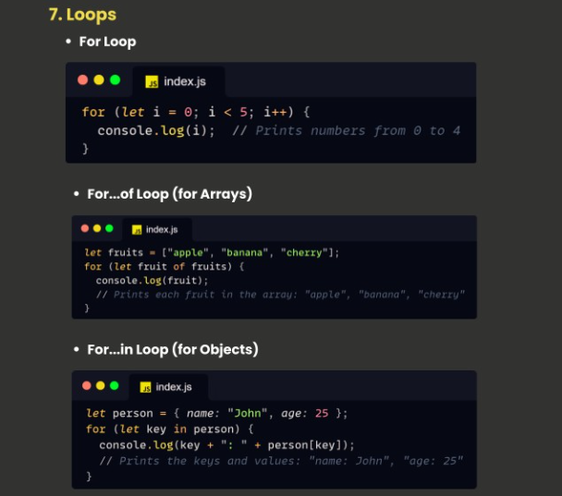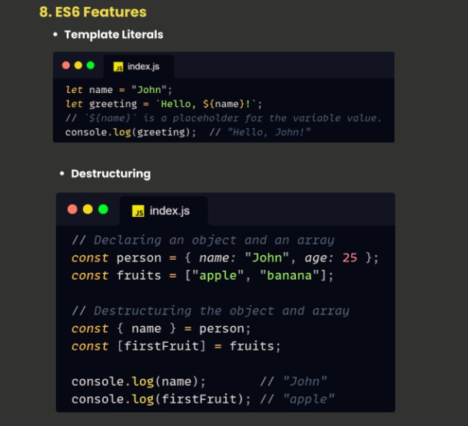
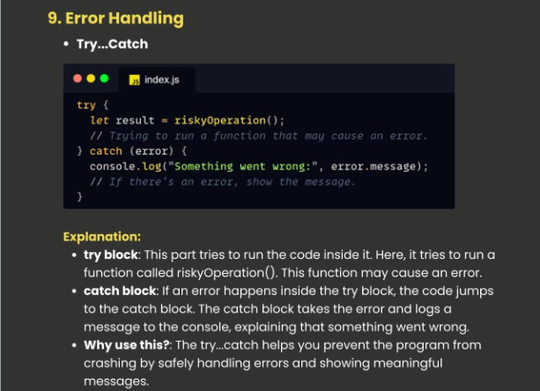
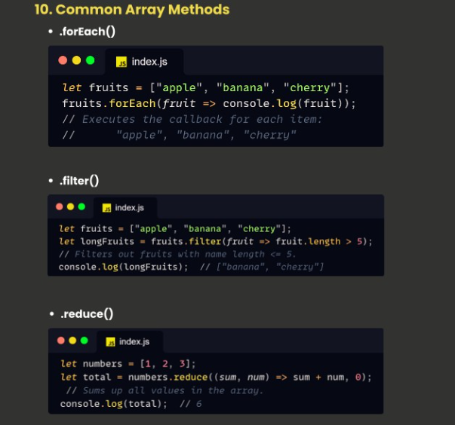

Javascript-DOM manipulation:
With the HTML DOM, JavaScript can access and change all the elements of an HTML document.The HTML DOM (Document Object Model, When a web page is loaded, the browser creates a Document Object Model of the page. The HTML DOM model is constructed as a tree of Objects:
With the object model, JavaScript gets all the power it needs to create dynamic HTML:
JavaScript can change all the HTML elements in the page
JavaScript can change all the HTML attributes in the page
JavaScript can change all the CSS styles in the page
JavaScript can remove existing HTML elements and attributes
JavaScript can add new HTML elements and attributes
JavaScript can react to all existing HTML events in the page
JavaScript can create new HTML events in the page
JavaScript can modify the DOM using methods like
- document.getElementById()
- querySelector()
- innerHTML
querySelector():
The querySelector() method returns the first element that matches a CSS selector.
To return all matches (not only the first), use the querySelectorAll() instead.
document.querySelector("p");
// this will only select the first p element in the document
getElementById():
Get the element with the specified id:
document.getElementById("demo");
//will select elements with the specified id
const myElement = document.getElementById("demo");
myElement.style.color = "red";

innerHtml ():
Gets or sets the HTML content inside an element.
It includes HTML tags inside the element.

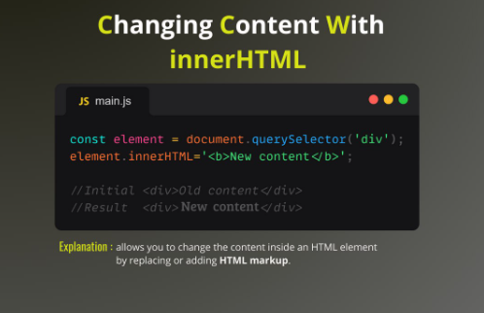

Javascript-Event Handling :
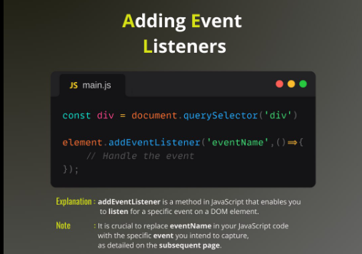

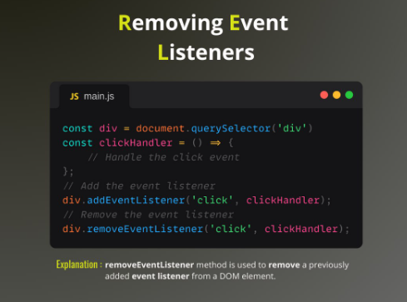
REGEX- Validation in Javascript:

1. Validating an Email Address
let regex = /^[a-zA-Z0-9._%+-]+@[a-zA-Z0-9.-]+\.[a-zA-Z]{2,}$/;
let mail = "test@example.com";
if (regex.test(mail)) {
console.log("Valid email address");
} else {
console.log("Invalid email address");
}
2. Validating a Phone Number
let regex = /^\d{10}$/;
let phone = "1234567890";
if (regex.test(phone)) {
console.log("Valid phone number");
} else {
console.log("Invalid phone number");
}
3. Validating a Password
let regex = /^(?=.*[a-z])(?=.*[A-Z])(?=.*\d)[a-zA-Z\d]{8,}$/;
let pass = "Password123";
if (regex.test(pass)) {
console.log("Valid password");
} else {
console.log("Invalid password");
}
- Validating a Username
let regex = /^[a-zA-Z][a-zA-Z0-9_]{5,19}$/;
let uName = "user_123";
if (regex.test(uName)) {
console.log("Valid username");
} else {
console.log("Invalid username");
}

BOM- Browser Object Model:
The Browser Object Model (BOM) is a set of JavaScript objects provided by the browser to interact with the browser itself. One of the objects in the BOM is a window, which represents the browser window.
BOM objects includes
Window, navigator, screen, location and history
- Window Object:
The window object represents the browser window and is the global object in JavaScript.
For Eg:
1. Opening a new window using BOM:
//opens a new blank google window
window.open("https://www.google.com", "_blank");

2. Showing an Alert:
window.alert("Hello! This is an alert.");

- Navigator Object:
The navigator object provides information about the browser.
For Eg:
1.Checking Browser name:
//checks the browser name
console.log("Browser Name: " + navigator.appName);

2.Checking if javascript enabled or not
//checks the javascript status
if (navigator.javaEnabled()) {
console.log("JavaScript is enabled!");
} else {
console.log("JavaScript is disabled!");
}

- Screen Object:
The screen object provides information about the user's screen.
For Eg:
1. Getting Width and height of the screen
console.log("Screen Width: " + screen.width);
console.log("Screen Height: " + screen.height);

- Location Object:
the location object contains information about the current URL.
For Eg:
1. redirecting to other url:
//redirecting
window.location.href = "https://www.example.com";
2. reloading the page:
//reload the page
window.location.reload(); "

- History Object:
The history object allows navigation through the browser's history or visited pages.
For Eg:
1.Moving forward and backward in visited history:
//go back to the previous page
window.history.back();
//go to the forward page
window.history.forward();

TASKS
Task 01: Write a function in which all types of Data types of JS will be used using LET, VAR, CONST and variable initialization.
Task 02: Write a function in JS which will reverse the String in ascending order.
Task 03: Write a JavaScript program to print the table of entered number in the web browser.
Task 04: Create a JavaScript program to display the simple Calculator which will perform basic arithmetic operations.
Task 05: Write a function to check if an input string is a palindrome and display the result of web page.
Task 06: Create a Sign up page and display the entered value after the
submission of form on the webpage using DOM.
Task 07: Validation is one of the important concept in the web page, create
a complete Sing up page having name, contact, email password, radio and
checkbox button on it and validate using JS regular expression individually
according to the user control.
Task 08: Using JS create an Image Slider that will move image automatically
after some delay, you have to create your own logic to do so.

